

T640**(E)**(M30)T

# APRIL EXAMINATION

**NATIONAL CERTIFICATE**



# FITTING AND MACHINING THEORY N2

(11022032)

**30 March 2016 (X-Paper)**

## 09:00–12:00

**Calculators and drawing instruments may be used.**

**This question paper consists of 8 pages and 1 formula sheet.**



-2- T640**(E)**(M30)T

## DEPARTMENT OF HIGHER EDUCATION AND TRAINING REPUBLIC OF SOUTH AFRICA

NATIONAL CERTIFICATE

FITTING AND MACHINING THEORY N2

TIME: 3 HOURS

MARKS: 100

NOTE: If you answer more than the required number of questions, only the required number of questions will be marked. All work you do not want to be marked



must be clearly crossed out.

**INSTRUCTIONS AND INFORMATION**

1.

2.

3.

4.

5.

6.

Answer ALL the questions in SECTION A

.

Answer either

QUESTION

1.1

o

r

QUESTION

1.2

of

Que

stion

1.

Answer only TWO questions in SECTION B.

Read ALL the questions carefully.

Number the answers according to the numbering system used in this question

paper.

Write neatly and legibly.

T640**(E)**(M30)T

**SECTION A**

### QUESTION 1: OCCUPATIONAL SAFETY

1.1 List FIVE factors to consider when constructing safety guards on machinery. **[5]**

OR

1.2 Describe what is meant by:

1.2.1 Illumination of machinery

1.2.2 Approved lamps in fiery mines and coal mines

|  |  |
| --- | --- |
| **QUESTION 3: LIMITS AND FITS**    3.1 Explain the meaning of the following terms used in connection with limits and fits:    3.1.1 Hole basis systems    3.1.2 Minimum allowance    3.1.3 Bilateral tolerance    3.1.4 Transition fit  (4 x 1)    3.2 A shaft is to be fitted into a bush. The following sizes are given for the shaft and the bush: | (4) |
| Shaft : f30--0,0250,035 Bush : f30+-0,0250,015    3.2.1 Determine the minimum allowance of the fitted parts | (3)  **[7]** |

1.2.3 Inspection and testing of boilers

1.2.4 Unprotected electrical cables

1.2.5 Lights to be carried

 (5 x 1) **[5]**

### QUESTION 2: COUPLINGS

State FIVE advantages of using short shafts joined by couplings instead of long shafts. **[5]**

-4- T640**(E)**(M30)T

### QUESTION 4: BEARINGS

4.1 List FOUR advantages of plain bearings. (4)

4.2 Name THREE tools that may be used to remove anti-friction bearing. (3)

**[7]**

### QUESTION 5: LUBRICATION AND VALVES

5.1 Name TWO types of shut-off valves. (2)

5.2 Differentiate between a normally open and a normally closed valve. (2)

|  |  |
| --- | --- |
| 6.1 Name any FOUR types of sealing materials used in pipeline installations. | (4) |
| 6.2 State THREE reasons for the lagging (insulating) of steam-pipelines. | (3) |
|  | **[7]** |
| **QUESTION 7: PUMPS** |  |
| 7.1 Name the TH~~REE categories into which pumps are classified.~~ | (3) |
| 7.2 Briefly explain the operation of a centrifugal pump. | (3) |
|  | **[6]** |

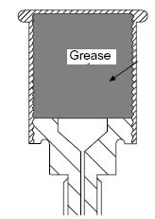5.3 Name the FOUR different types of lubricators shown in FIGURE 1 below.

Write only the answer next to the question number (5.3.1–5.3.4). in the ANSWER BOOK.

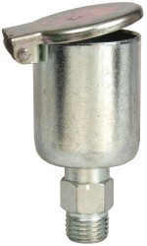

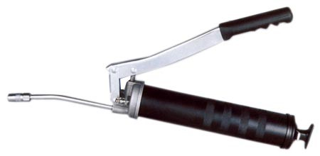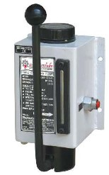

5.3.1 5.3.2 5.3.3 5.3.4

**FIGURE 1** (4 x 1) (4)

**[8]**

### QUESTION 6: PACKING, STUFFING BOXES AND JOINTS AND WATER-PIPE SYSTEMS

Please turn over

T640**(E)**(M30)T

### QUESTION 8: COMPRESSORS

Name the FIVE compressor components labelled 8.1 – 8.5 in FIGURE 2 below. Write only the name of the component next to the question number (8.1–8.5) in the ANSWER BOOK.

**FIGURE 2 [5]**

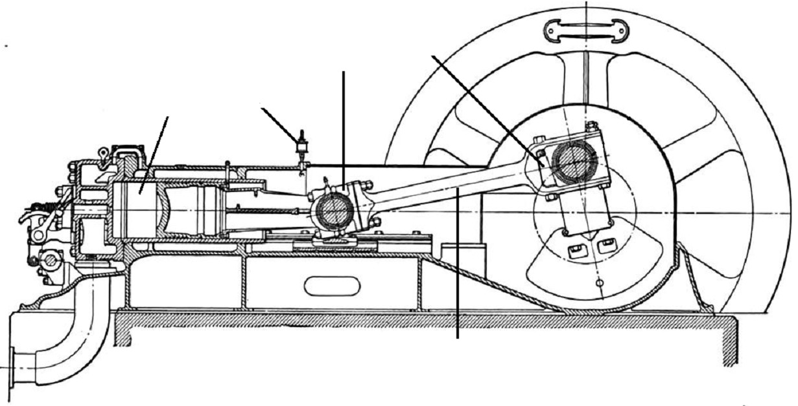

8.1

8.2

8.5

8.4

8.3

### QUESTION 9: V-BELT, CHAIN, GEAR DRIVES AND REDUCTION GEARBOXES

9.1 Explain the following terms relating to chain drives:

9.1.1 Chain pitch

9.1.2 Drive sprocket

(2 x 1) (2)

9.2 State TWO reasons for the use of a guard on chain drives. (2)

9.3 State THREE precautions to be taken when working on V-belt drives. (3)

9.4 List THREE advantages of gear drives over belt and chain drives. (3)

### [10]

**TOTAL SECTION A: 60**

Please turn over

T640**(E)**(M30)T

**SECTION B**

Answer only TWO of the questions in this section.

### QUESTION 10: HYDRAULICS AND PNEUMATICS

10.1 Name the components (10.1.1–10.1.5) associated with the ISO symbols in FIGURE 3 below. Write only the name of the component next to the question number (10.1.1–10.1.5) in the ANSWER BOOK.

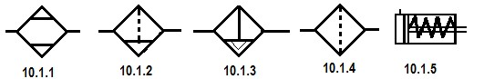

**FIGURE 3** (5)

10.2 Describe the main difference between a *pneumatic system* and a *hydraulic*

*system.* (2)

10.3 List the THREE ways by which directional control valves can be actuated. (3)

10.4 State the function of the following hydraulic components:

10.4.1 Hydraulic motor

10.4.2 Tank/Reservoir

10.4.3 Pressure-relief valve

(3 x 1) (3)

10.5 List TWO functions of valves in a hydraulic system. (2)

10.6 Name the components associated with the ISO symbols in FIGURE 4 below. Write only the name of the component next to the question number (10.6.1– 10.6.5) in the ANSWER BOOK.

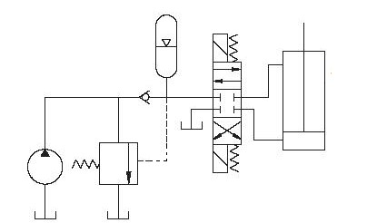

10.6.4

10.6.2

10.6.5

10.6.3

10.6.1

**FIGURE 4** (5)

### [20]

Please turn over

T640**(E)**(M30)T

### QUESTION 11: CENTRE LATHES

11.1 Briefly describe how the following lathe mandrels operate:

11.1.1 Sliding cone mandrel

11.1.2 Expanding mandrel

(2 x 2) (4)

11.2 The compound slide is used for taper turning on a centre lathe.

11.2.1 State TWO advantages of the use of the compound slide

11.2.2 State TWO disadvantages of the use of the compound slide

(2 x 2) (4)

11.3 State TWO methods of tailstock set-over, as applicable to taper-turning. (2)

11.4 Explain the main difference between the *travelling steady* and the *fixed steady*

used on centre lathes (2)

11.5 A taper of 1 in 40 has to be turned on a workpiece 280 mm long. Calculate

the amount of tailstock set-over required. (3)

11.6 A round shaft with an outside diameter of 45 mm must be provided with a two-

start thread with a 10 mm pitch. Calculate the helix angle of the thread (θ). (5)

**[20]**

### QUESTION 12: MILLING MACHINES AND SURFACE GRINDERS

12.1 Identify the milling cutter types shown in FIGURE 5 below. Write the answers next to the question number (12.1.1–12.1.3) in the ANSWER BOOK.



**FIGURE 5**

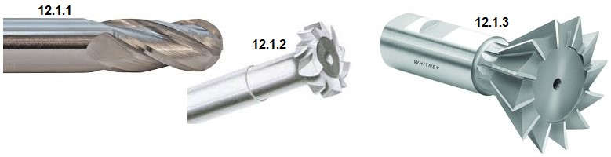

(3)

|  |  |
| --- | --- |
|  |  |
| 12.2 Name any FOUR components of a dividing head. | (4) |
| 12.3 State THREE possible factors which cause the burning of the workpiece when surface grinding. | (3) |

Please turn over

12.4 Calculate the cutting speed of the cutter, in metres per minute, when using a cutter of 40 mm in diameter at a speed of 302 revolutions per minute. (3)

12.5 Climb milling is one of many milling processes.

12.5.1 Explain climb milling with the aid of a freehand drawing. (5)

 12.5.2 State TWO advantages of climb milling. (2)

### [20]

**TOTAL SECTION B: 40**

**GRAND TOTAL: 100**

 

(11022032) T640**(E)**(M30)T

### FITTING AND MACHINING THEORY N2

**FORMULA SHEET**

f = ft ´ ´ T N

S = π D N

60

S = π D n

40

N

N

9°

Set-over = D - d ´ length of workpiece

2 length of taper

Set-over = length of workpiece ´ Ratio 2

tan θ = X

2 L

Leading angle = 90 - (Helix angle + clea° rance angle)

Following angle = 90 + (Helix angle - cleara° nce angle)

Lead = No. of starts ´ pitch

Mean diameter = OD - Pitch 2

tan θ = Lead

Mean circumference